Student ID | IT23588714
Batch | WE B01.1
Marking Guide
- Ideation | 2
- Applying “60-30-10 rule” when deciding the colors | 2
- Selecting suitable layouts | 2
- Using proper views for the user interface | 2
- Interactivity | 1
- Creativity | 1
Total Marks | 10
Evaluator

Description:
Teenagers can use the contemporary Teezy app, which offers a carefully chosen selection of fashionable clothing. Users may browse the newest and replenished fashion outfits, manage shipment information, update their profiles, and safely add payment methods thanks to an easy to use interface. With vivid designs and reasonable costs, Teezy offers a smooth shopping experience with categories like shirts, jeans, caps, and gym clothing. The app showcases limited-edition collections, offers color and size options, and has a wishlist feature.

Screenshots:
Splash Screen
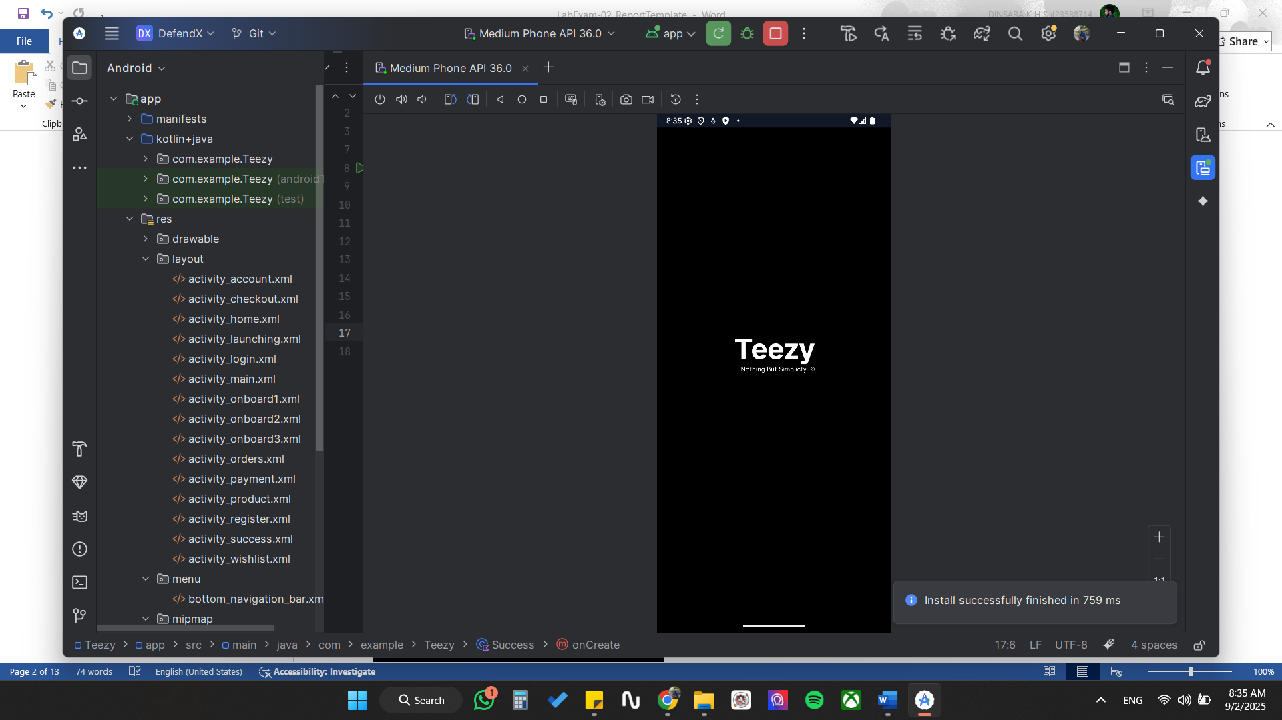

Onbourding Screen 01
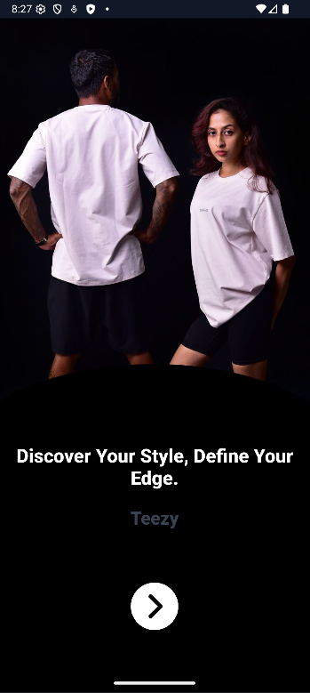

Onbourding Screen 02
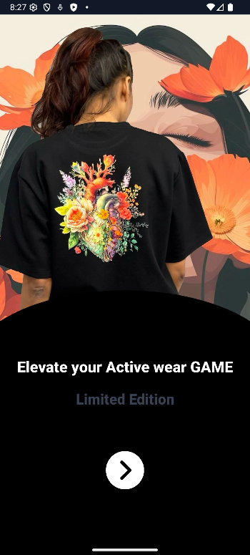

Onbourding Screen 03
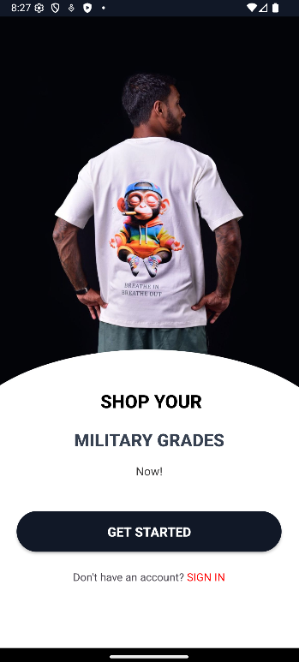

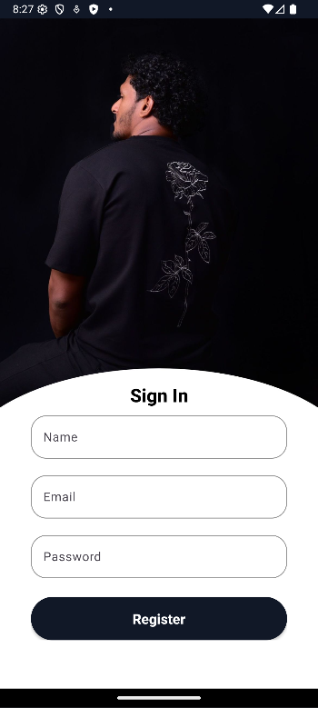
Sign In

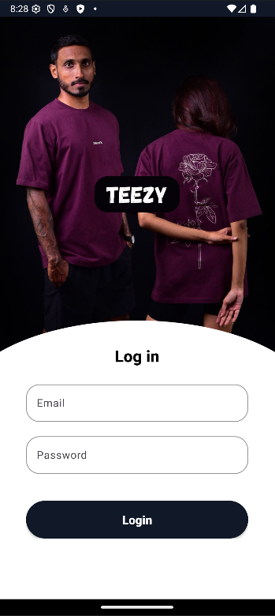
Log In

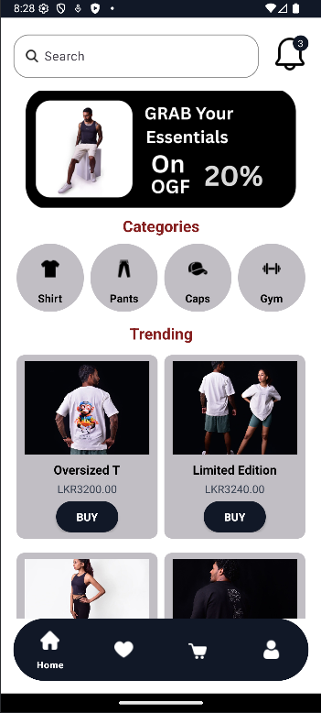
Home

Item Description
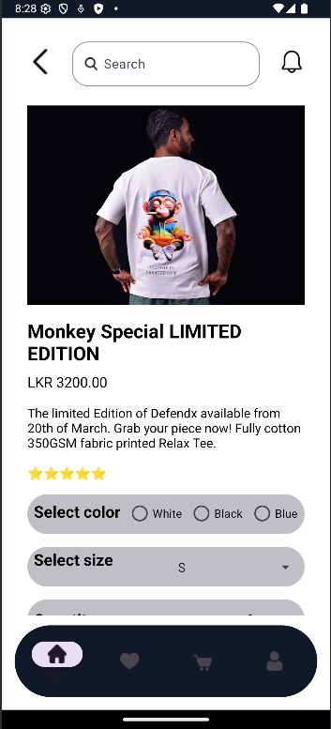

Shipping
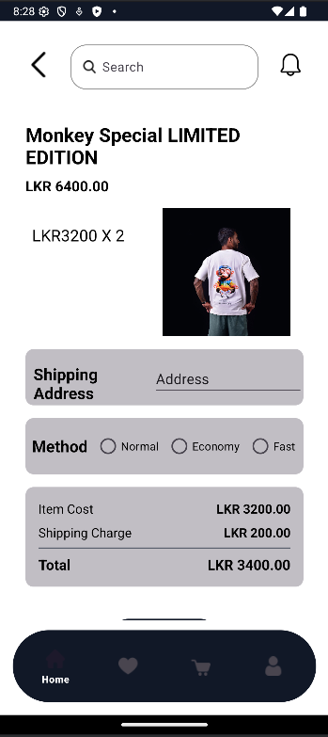

Payment
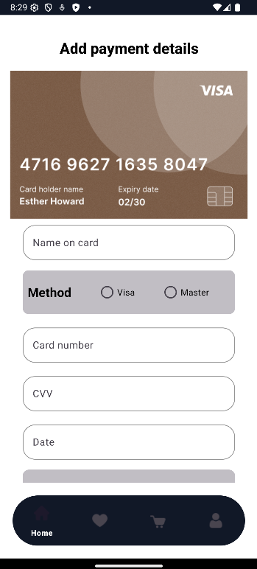

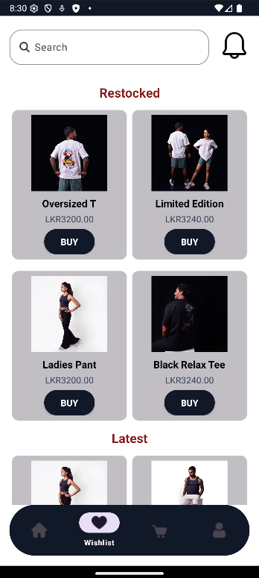
Wishlist

Profile
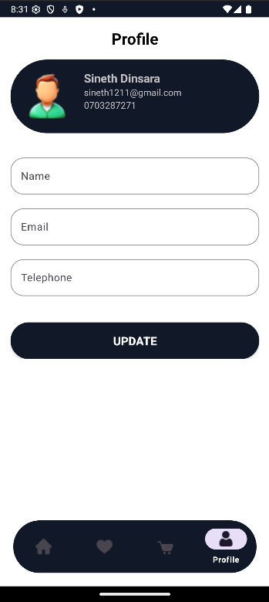

Content of xml files of Strings and Colors:
Strings

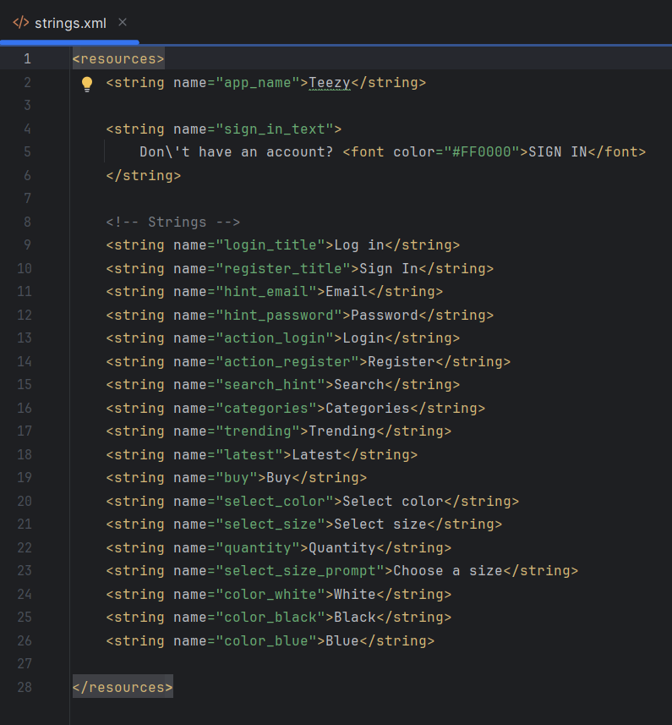

Colors
